**LOSC Lille vs Chelsea FC Preview**

Chelsea who had a good weekend by defeating Brighton Hove 2-0 will look to continue their winning run. Frank Lampard who as a player for Chelsea, won against Valencia back in 2007 twice, and once in 2012 had a bad start by losing 1-0 at home, will now be looking to win this fixture against Lille. Chelsea have never met Lille before in official competion and this would their 1st fixture in history

**Chelsea Current Form**

Chelsea with a steady start this season, have been giving chances to youngsters, many talents were unleashed. Tomori, Hudson-Odoi, Abraham, Mount etc. but however Pulisic who looked promising after signing for the club is frustrated due to lack of match timings. Frank Lampard’s side who are currently in 7th position in Premier League, are 1 point behind 4th placed Arsenal, will back his young stars to shine away from home Wednesday Night.

Pic : Mason Mount and Tammy Abraham have been core player for this season under their gaffer Frank Lampard

**Team News**

N’Golo Kante who missed Saturday’s game against Brighton, trained with Chelsea ahead of Champions League clash in France. Zouma and Giroud also trained with the team, but Rudiger, Loftus-Cheek and Emerson remains side lined

Meanwhile Timothy Weah, Lille midfielder is doubtful for the French side, who is co-incidentally son of ex-Chelsea player George Weah

**Expected line up from Chelsea**

Chelsea would be expected to field 4-3-3 formation. Frank Lampard who would be looking to win this tricky fixture, will field complete strong team. The below image is the team we can expect for tonight’s match

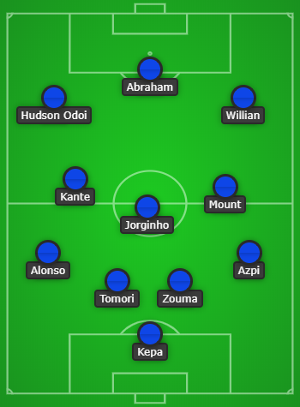

**Key Facts**

Chelsea have won seven of their last 12 away games in the UEFA Champions League (W7 D2 L3). The Blues lost their last two UCL matches and have never lost three in a row. Frank Lampard will hope to maintain that record as he fields a determined a starting XI at the Stade Pierre-Mauroy

**List of players who played for both Chelsea and Lille**

**Joe Cole**: Chelsea legend who won 3 PL Titles, 3 FA Cups and 2 League cups in 7 seasons, from 2003-2010, singed for Lille in 2011-12 season while on loan from Liverpool

**Eden Hazard**: After winning the 2012 Champions League, Eden Hazard signed for Chelsea FC, who had an amazing career by winning 2 PL Titles, 2 Europa League, 1 League Cup and 1 FA Cup

**Salomon Kalou**: Yet another core member of the Chelsea team from 2006-2012, who also featured in 2012 Champions League finals, joined Lille after the CL Finals on a free transfer

**Left :** Joe Cole and Eden Hazard played together at Lille for 2011-12 season

**Right** : Joe Cole and Eden Hazard during their Chelsea stint